Assignment 1st :
Deploy index.html file using Jenkins job
1) yum install httpd -y
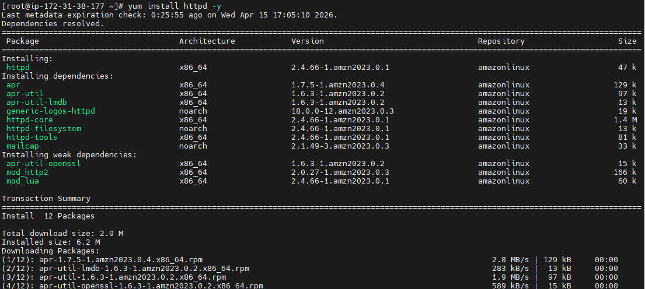
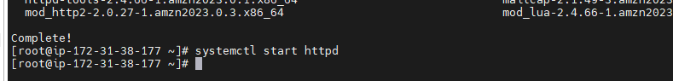
Created remote repository :
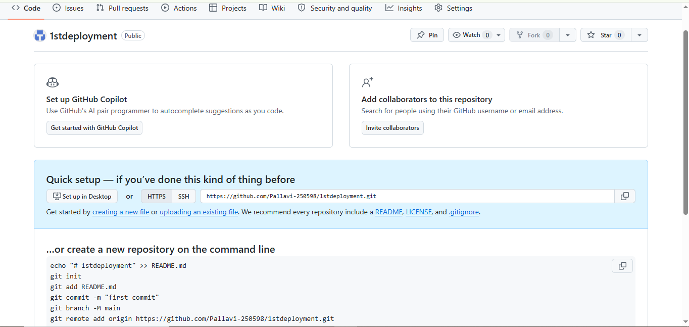
Created local repo :
vi index.html push it to remote repo :
Git add /Git commit /Git add origin and push
Remote repository :
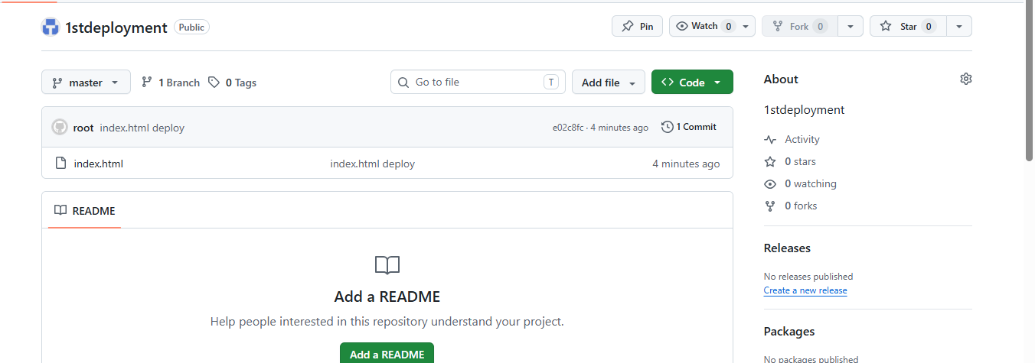
Create one job in jenkins:
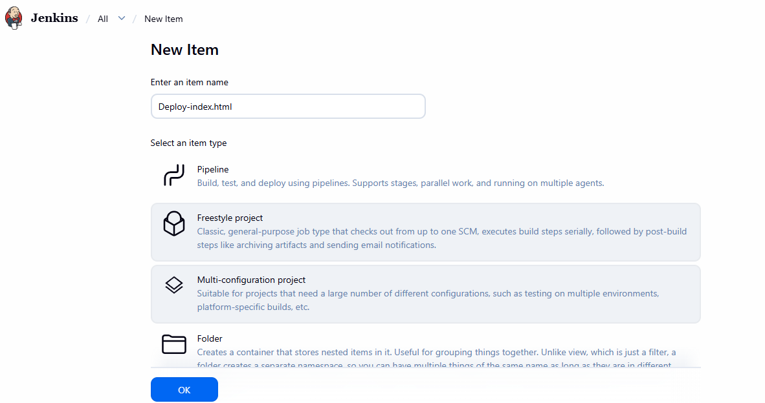



Do changes in source code mngmnt :
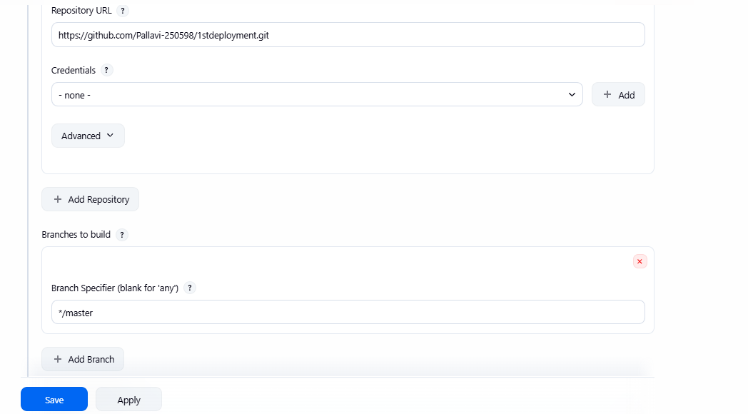
add in build steps Execute shell
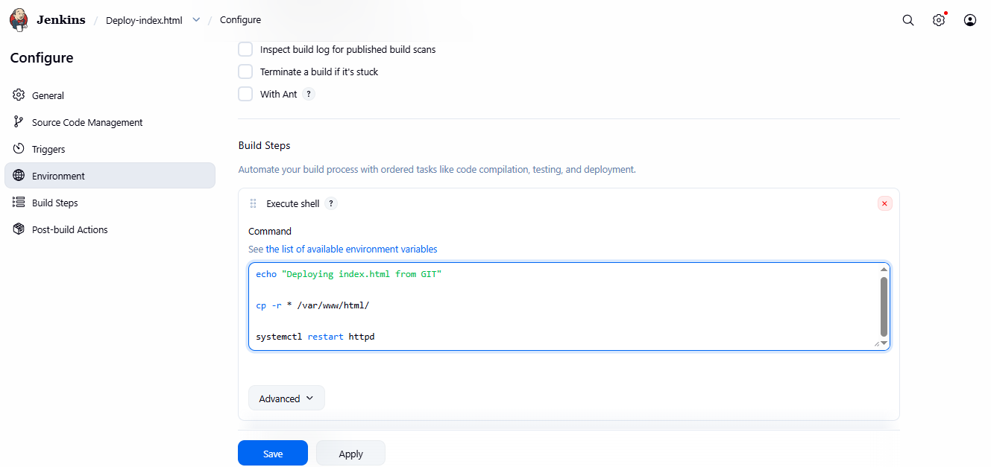

Build deployed :
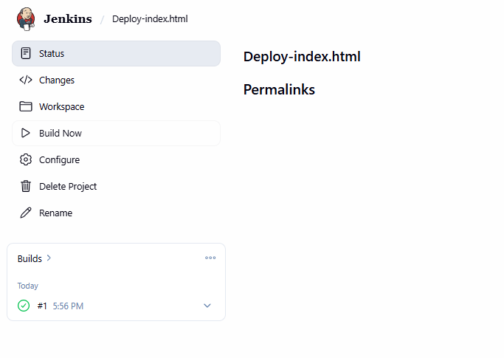
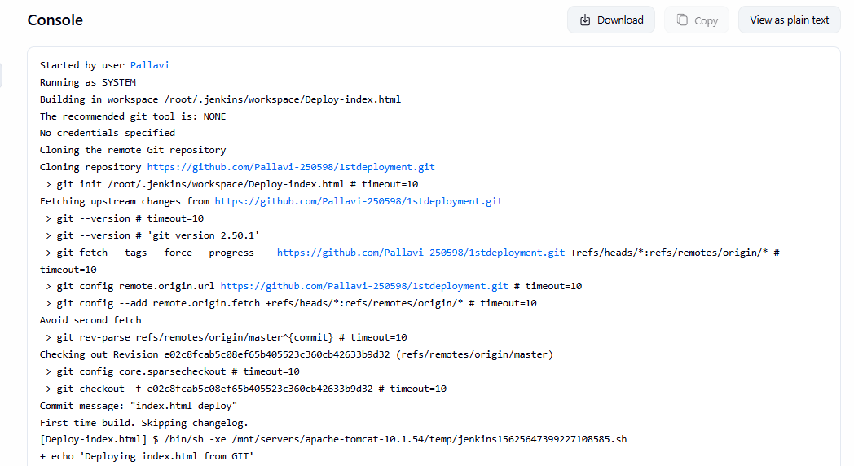

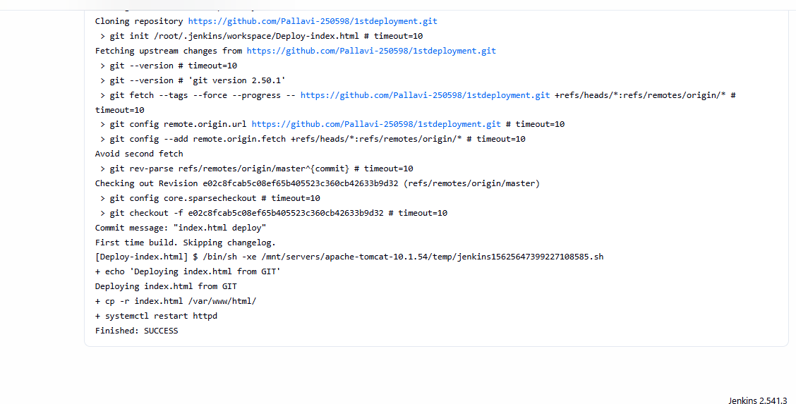

chmod -R 755 /var/www/html
chown -R jenkins:apache /var/www/html
Website working fine
